2024 ASIA Families Camp Rice
Korean Culture Family/Teen Camp
July 25-27, 2024 (Thursday 9:00 a.m. through Saturday 1:30 p.m.)
Pearlstone Conference and Retreat Center
5425 Mt. Gilead Road
Reisterstown, Maryland 21136
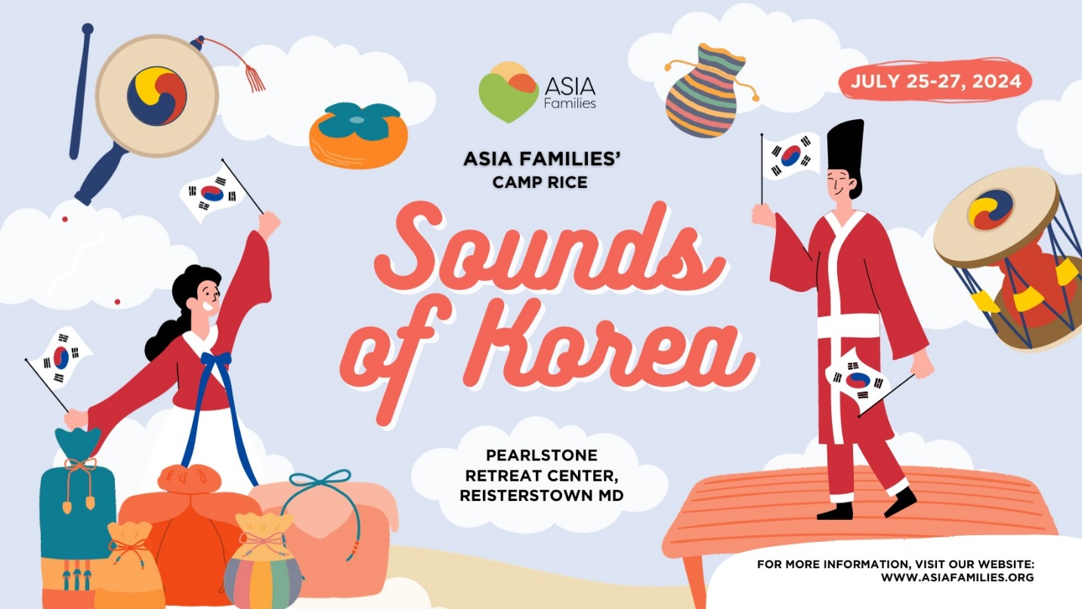

2024 Camp Rice Registration Form

2024 Camp Rice Registration Form (jotform.com)

You are invited to ASIA Families' Annual Family Camp, taking place from July 25th to July 27th, 2024 (Thursday, 9:00 a.m. through Saturday, 1:30 p.m.). This year's theme is "Sounds of Korea," and we are excited to offer a diverse range of activities and classes to explore the rich Korean culture while celebrating the beauty of Korean children and youth.

Our programs are designed to accommodate a wide range of participants. We have separate family and teen camps, ensuring that there's something for everyone. The family camp provides engaging activities for school-age children aged 3 and above, as well as for adults, including adoptive parents and adult adoptees.

Who is Eligible to Attend?

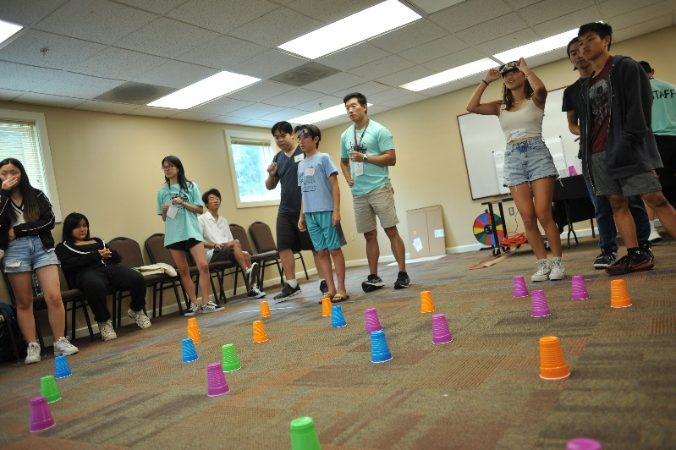
- All adoptive families with Korean children of varying ages and their siblings are wholeheartedly invited to participate.
- Adult adoptees and their children
- Non-adoptive siblings and children from countries other than Korea are equally embraced.

Rooming Arrangements at Camp

- Adults and young children, ranging from PreK to rising 8th graders, stay together in hotel-style rooms. Parents of the young campers must register and stay overnight at the campsite with their children.
- Our Teen Camp takes place within the same facility, but it is located in a separate section of the retreat center.
- Teens entering 8th grade and above are considered teen campers.
- (New) Rising 8th graders share rooms with their parents or legal guardians.
- (New) Campers in 9th, 10th, 11th, and 12th grades room with their fellow teen campers. Parents of 9th through 12th graders are not required to register or stay at the camp, although we warmly welcome them to join us and experience Camp Rice together.

Accommodations and location

Pearlstone Conference and Retreat Center, located in Reisterstown, MD, is conveniently situated just 20 minutes from Baltimore. Our accommodations for family campers are designed for comfort, offering hotel-style rooms complete with linen services. Each room is equipped with a private bathroom, including a shower, and has the capacity to sleep up to 6 people. Most rooms feature two double-sized beds and provide ample space for rollaway beds or cribs, which we can arrange for as needed (please refer to the registration form). All of our lodges are equipped with air-conditioning for your comfort.

To ensure a restful night's sleep, a set of linens will be provided for each sleeping camper. Pearlstone takes pride in serving delicious home-cooked meals prepared in a kosher kitchen. We are also equipped to accommodate food allergies with our menu offerings. Notably, our Center boasts a 5-acre farm on-site, which supplies fresh produce to our kitchen.

For more information about our camp facility, we invite you to visit their website at Pearlstone Center. Additionally, free wireless Internet services are available in the main building for your convenience.

Schedule and Program
Check-in/Registration will begin at 9:00 a.m. on Thursday, July 25, 2024. We will all gather at 10:30 a.m. for Welcome and Announcements. Morning classes on the first day will begin at 10:50 a.m.
On the last day, we host a closing ceremony at 1:30 p.m.
During the classes, children will be supervised by adult adoptee counselors and Korean-American young adults.
Parents need to pick up their children for meals, free time, and performances and presentations at our large group gathering space.

Typical Camp Schedule
July 25 (Thursday)
Check-in starts at 9:00 a.m. (Leave your suitcases in your car.)
Classes begin at 10:50 a.m.
Lunch
Classes
Free time at 4:00 p.m. (swimming pool opens at 4:00 p.m. to 6:00pm)
Room Check-in at 4:00 pm (Please be aware of the late room check in time)
Dinner
Welcoming event/opening ceremony

July 26 (Friday)
Breakfast
Classes
Lunch
Classes
Free time at 3:00pm (swimming pool opens 3:00pm to 5:00pm)
Dinner
Performances

July 27 (Saturday)
Breakfast
Check out /Key Return by 10:00 a.m.
Classes
Lunch
Closing ceremony at 12:30 p.m.
Camp ends at 1:30 p.m.

Teen Program

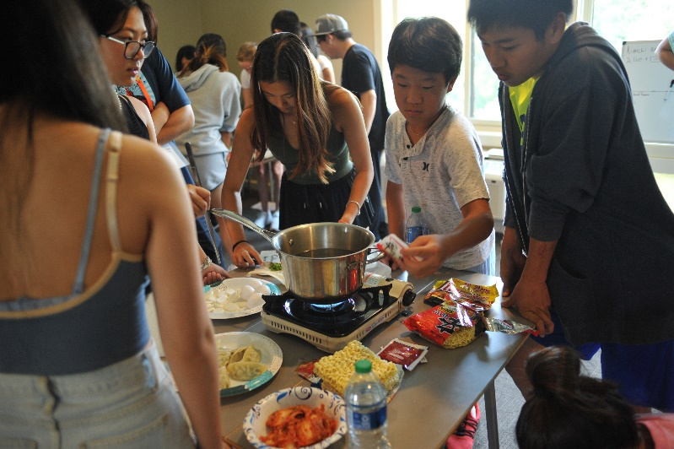
Campers aged from 8th to 12th grade will be joining our program specifically designed for teens. Our teen program curriculum includes various classes and workshops that focus on integrating Korean culture, building leadership and teamwork, delivering structured role modeling, supporting personal growth by accommodating a safe and trusting environment, and most importantly, providing fun activities for the teens to treasure looking back.

What age is considered a teen camper?
Teen campers are students who are rising 8th grade through 12th grade by Fall of 2024.

Teen campers who are rising 9th, 10th, 11th and 12th grade, will be lodging in Garden Lodge with other teen campers. Teen campers of rising 11th graders through 12th graders can be dropped off at camp alone for the weekend if the parents are unavailable to participate in the camp.

Teen campers rising 8th graders, will be lodging with their parent(s) in hotel-style rooms although they will be fully participating in the teen program. Therefore, full registration and physical presence of parent(s) of rising 8th graders are required for their teen to participate in the teen program.

If you have a teen camper and younger campers, it is recommended that your teen campers stay with other teens if your family will be staying overnight at the camp. We have had birth siblings who came to our camp in the past. It is their choice if they would like to join the teen program or family camp program.

Adult Program
Adult adoptees and adoptive parents are encouraged to participate in our adult program, tailored to offer enrichment workshops, networking opportunities, and, of course, enjoyable activities. In the past, our adult program has featured engaging sessions with keynote speakers, Q&A sessions with adoptee panels, and opportunities to explore Korean culture through small group activities. These activities may include, but are not limited to, cooking, arts and crafts, and field projects.

Registration Fee
The full camp registration fee includes overnight accommodations, 7 meals, a camp T-shirt, snacks and camp programs: $550 per person. Payment is required upon registration for the camp.
2024 camp fee refund policy
Cancellation by February 30- 75 percent refund
Cancellation by April 30- 50 percent refund
Cancellation by June 1- 25 percent refund
Unfortunately, no refunds will be provided for cancellations made after June 1.

Camp counselors
For Adult Adoptees and Korean-American friends who are interested in volunteering:

If you are enthusiastic about volunteering as a group leader/counselor for children or teens, please note that you should be 18 years or older and able to pass a criminal background check.

To apply, each applicant must submit their application to ASIA Families and it is first come first serve in early January.

Please be aware that this is a voluntary role, and there is no compensation provided. Additionally, volunteers are responsible for their transportation to and from the camp location.

For more information and to express your interest, please feel free to contact our camp director, Jane Yoo, at jyoo@asiafamilies.org.

Your participation is greatly appreciated!

Financial assistance for campers
If your family recently experienced unemployment and financially cannot afford to send your teen to Camp Rice, please write to us at info@asiafamilies.org. We will be doing some fundraisers and will be able to offer a few scholarships for campers.

Would you like to sponsor an adult adoptee counselor to come to the camp?
Camp Rice is a place where adult adoptees get together once a year to give their time and energy to mentor younger adoptees. They are a great asset to the Camp Rice program. In order to host one counselor, it costs us $550 If you can make a donation of $550, $275 or another amount, we can bring more adult adoptees to join the camp. Help us continue this valuable tradition. Donation HERE.

How to register
To reserve your spot, fill out the online form.
2024 Camp Rice Registration Form (jotform.com)

Contact us
If have a question about camp registration, counselor application form, camp curriculum, accommodations or volunteering, contact our camp director, Jane Yoo at jyoo@asiafamilies.org.

All other questions regarding financial assistance, sponsorship, donation etc., please contact Grace Song, Executive Director, at info@asiafamilies.org.

